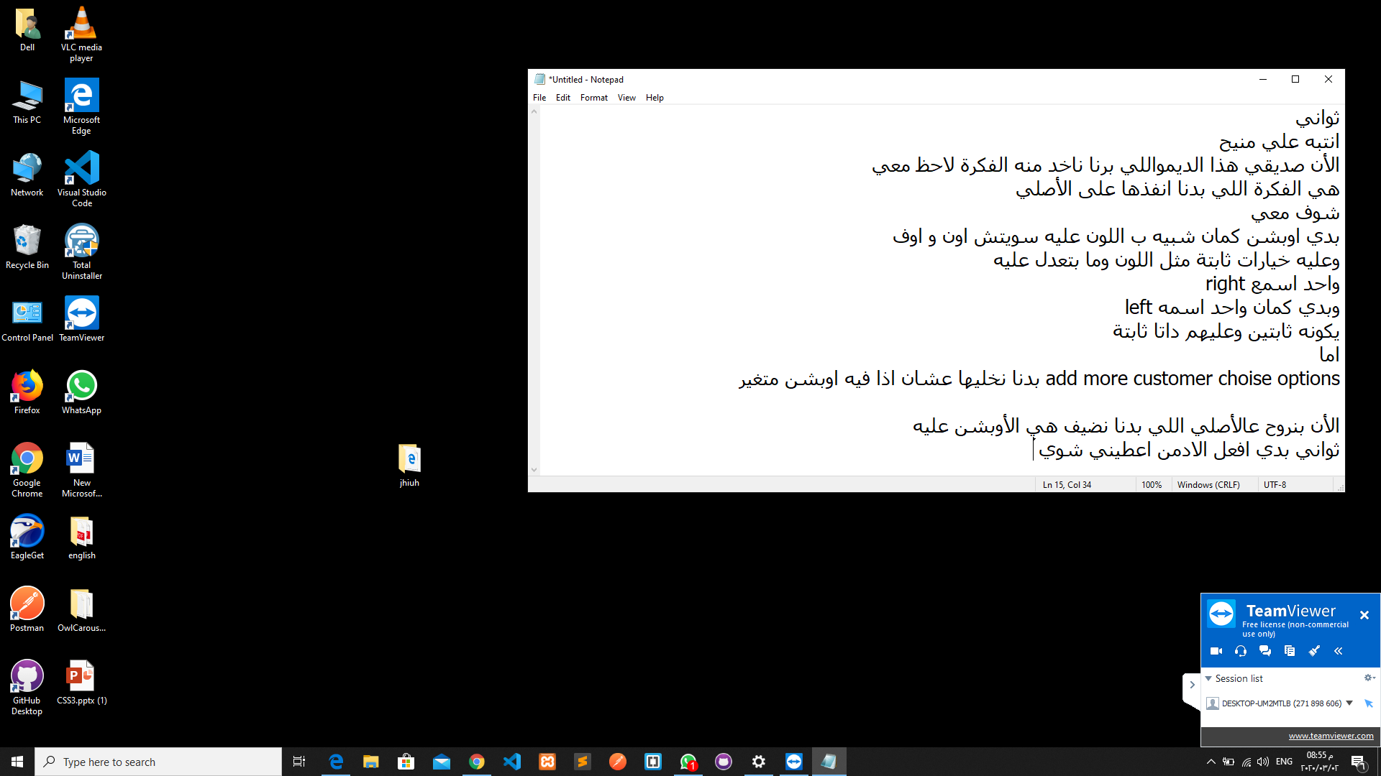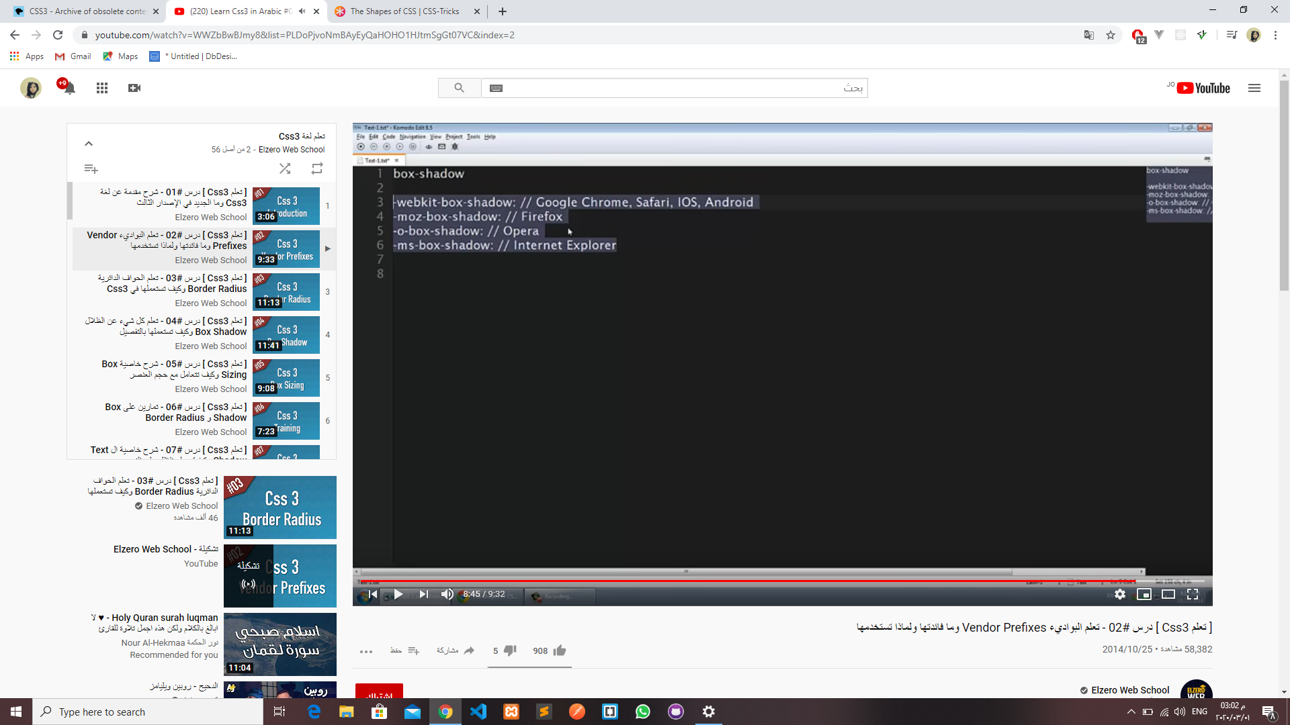@extends('layout.index')

@section('content')

<?php

$Institution =json_decode($Institution);

?>

<section class="forms">

    <div class="container-fluid">

      <!-- Page Header-->

      <header>

        <h1 class="h3 display d-flex justify-content-center">@lang('dashboard.dashboard.Institution_Details') </h1>

      </header>

      <div class="row">

        <div class="col-lg-9">

          <div class="card">

            <div class="card-header d-flex align-items-center">

              <h4>@lang('dashboard.dashboard.Institution_Details')</h4>

            </div>

            <div class="card-body ">

              <p>@lang('dashboard.dashboard.Profile_information')</p>

              <form class="form-row">

                <div class="form-group col-md-6">

                  <label>@lang('dashboard.dashboard.Institution_Name')</label>

                  {{-- @foreach ($Institution as $data)

                <input type="text" name="Institution_Name" value="{{$data->Institution_Name}}" placeholder="Institution_Name" class="form-control">

               @endforeach --}}

               <input type="text" name="Institution_Name" value="{{$Institution->Institution_Name}}" placeholder="Institution_Name" class="form-control">

                </div>

                <div class="form-group col-md-6">

                  <label>@lang('dashboard.dashboard.Institution_Address')</label>

                  <textarea placeholder="Institution_Address" value="{{$Institution->Institution_Address}}"  name="Institution_Address" class="form-control"></textarea>

                </div>

                <div class="form-group col-md-6">

                    <label>@lang('dashboard.dashboard.Institution_Email')</label>

                    <input type="email" name="Institution_Email" value="{{$Institution->Institution_Email}}" placeholder="Institution_Email" class="form-control">

                </div>

                <div class="form-group col-md-6">

                    <label>@lang('dashboard.dashboard.Institution_Phone')</label>

                    <input type="tel" name="Institution_Phone" value="{{$Institution->Institution_Phone}}" placeholder="Institution_Phone" class="form-control">

                </div>

                <div class="form-group col-md-6">

                    <label>@lang('dashboard.dashboard.Institution_Mobile')</label>

                    <input type="tel" name="Institution_Mobile"  value="{{$Institution->Institution_Mobile}}" placeholder="Institution_Mobile" class="form-control">

                </div>

                <div class="form-group col-md-6">

                    <label>@lang('dashboard.dashboard.Institution_Fax')</label>

                    <input type="text" name="Institution_Fax" value="{{$Institution->Institution_Fax}}"  placeholder="Institution_Fax" class="form-control">

                </div>

                <div class="form-group col-md-6">

                    <label>@lang('dashboard.dashboard.Admin_Contact_Person')</label>

                    <input type="text" name="Admin_Contact_Person" value="{{$Institution->admin_id}}"  placeholder="Admin_Contact_Person" class="form-control">

                </div>

                <div class="form-group col-md-6">

                    <label>@lang('dashboard.dashboard.Country')</label>

                    <input type="text" name="Country"  value="{{$Institution->Country}}" placeholder="Country" class="form-control">

                </div>

                <div class="form-group col-md-6">

                    <label>@lang('dashboard.dashboard.Currency_Type')</label>

                <input type="text" value="{{$Institution->Currency_Type}}" name="Currency_Type" placeholder="Currency_Type" class="form-control">

                </div>

                <div class="form-group col-md-6">

                    <label>@lang('dashboard.dashboard.Language')</label>

                    <input type="text" name="Language" placeholder="Language" value="{{$Institution->language}}" class="form-control">

                </div>

                <div class="i-checks col-md-6">

                    <input id="checkboxCustom2" type="checkbox"  value="" checked="" class="form-control-custom">

                    <label for="checkboxCustom2">@lang('dashboard.dashboard.Institution_code_check')</label>

                </div>

                <div class="form-group col-md-3">

                    <label>@lang('dashboard.dashboard.Institution_Code')</label>

                    <input type="text"  value="{{$Institution->Institution_Code}}"  name="Institution_Code" placeholder="Institution_Code" class="form-control">

                </div>

                <div class="form-group row">

                    <label class="col-sm-6 form-control-label">@lang('dashboard.dashboard.Timezone')</label>

                    <div class="col-sm-10 mb-3">

                      <select name="Timezone" class="form-control">

                      <option > {{$Institution->Timezone}}</option>

                      </select>

                    </div>

                </div>

                <div class="form-group col-md-12">

                  <input type="submit" value="Signin" class="btn btn-primary">

                </div>

              </form>

            </div>

          </div>

        </div>

        <div class="col-lg-3">

            <div class="card  d-flex align-items-center">

              <div class="card-header d-flex align-items-center">

                <h1>{{$Institution->Institution_Name}}</h1>

              </div>

              <div class="card-body d-flex align-items-center">

                <p><img style="width: 100%;" src="{{url("/storage/images/".$Institution->logo)}}"  class="rounded-circle"></p>

              </div>

              <h3>{{$Institution->Institution_Email}}</h3>

              <h3>{{$Institution->Institution_Phone}}</h3>

            </div>

          </div>

      </div>

    </div>

</section>

@endsection

  <p><img style="width: 100%;" src="{{url("/storage/images/".$Institution->logo)}}"  class="rounded-circle"></p>

  Schema::create('students', function (Blueprint $table) {

            $table->bigIncrements('id');

            $table->integer('student_admission_no')->nullable(false);

            $table->date('student_admission_date')->nullable(false);

            $table->string('student_firstname')->nullable(false);

            $table->string('student_middlename')->nullable(false);

            $table->string('student_lastname')->nullable(false);

            $table->string('email')->unique();

            $table->timestamp('email_verified_at')->nullable();

            $table->string('password');

            $table->string('phone')->nullable(false)->unique();

            $table->smallInteger('gender', false, true)->default(0);

            $table->string('city')->nullable(false);

            $table->string('state')->nullable(false);

            $table->string('street')->nullable(false);

            $table->string('placeOfBirth')->nullable(false);

            $table->integer('ID_number')->nullable(false)->unique();

            $table->smallInteger('statuse', false, true)->default(0);

            $table->string('avatar')->nullable(false);

            $table->unsignedBigInteger('guardian_id')->nullable(false);

            $table->rememberToken();

            $table->timestamps();

            $table->foreign('guardian_id')->references('id')->on('guardians');

        });

<?php

namespace App\Models;

use Illuminate\Notifications\Notifiable;

use Illuminate\Foundation\Auth\User as Authenticatable;

use Illuminate\Database\Eloquent\Model;

class Student extends Authenticatable

{

    use Notifiable;

    protected $guard = 'employee';

    protected $fillable = [

        'student_admission_no','student_admission_date','student_firstname','student_middlename','student_lastname', 'email', 'password','phone','gender','city','state','street','placeOfBirth','ID_number','statuse','avatar','guardian_id'

    ];

    protected $hidden = [

        'password', 'remember_token',

    ];

}

        // $Institution = Institution::latest()->get();

        // return view('admin.Institution')->with('Institution',$Institution);

        // return response()->json(array('success' => true, 'last_insert_id' => $data->id), 200);

        // return view('admin.InstitutionDetails' , compact('Institution'));

        // $Institution = Institution::latest()->first();

        // return response()->json(['Institution' =>$Institution]);

        // $Institution = Institution::latest()->first();

        // return view('admin.InstitutionDetails',[

        //     "Institution"=>json_encode($Institution)

        // ]);

        # first

        // $Institution = Institution::find($id);

        // return view('admin.InstitutionDetails' , compact('Institution'));

        #second

        // $Institution = DB::table('institutions')->get();

        // return view('admin.InstitutionDetails',['Institution' => $Institution]);

        #third

    //     $Institution = DB::getPdo()->lastInsertId();

    //    return response()->json(array('success' => true, 'last_insert_id' => $data->id), 200);

        // return view('admin.InstitutionDetails',['Institution' => $Institution]);

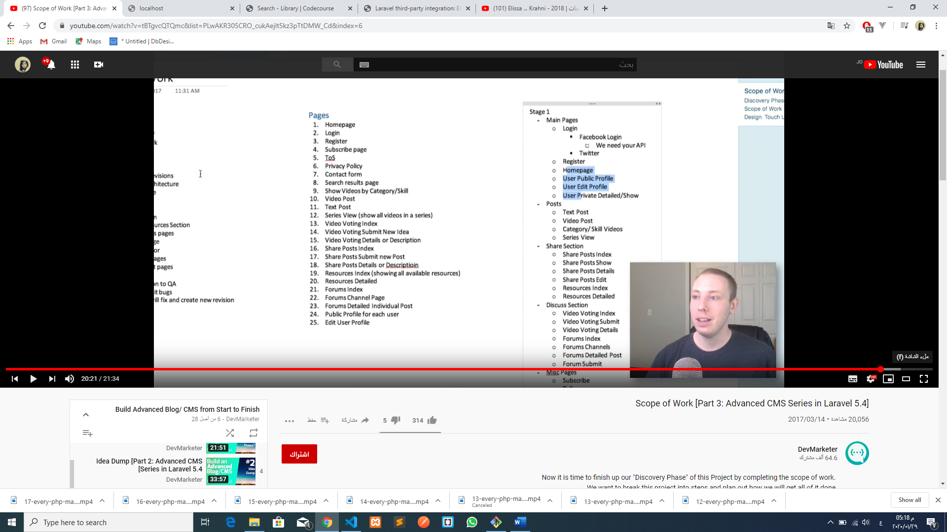

   // $class = ActivitySchool::where('classes_id')->get();

        // $class=ActivitySchool::find(1)->classes()->get();

        // $class=ActivitySchool::find('classes_id')->classes()->get();

        // $class=ActivitySchool::with('classes')->find(1);

        // $class=ActivitySchool::where('id', 1)->with('classes')->first();

        /////////////////////////////////////////////////

        // $class=ActivitySchool::find(1)->classes()->get();

        // $class=ActivitySchool::latest()->classes()->first();

        /////////////////////

        // $calss=ActivitySchool::with('classes')->lastest()->get();

        // $class=ActivitySchool::with('classes')->latest()->get();